Assignment: 2D Mini Shooting Game (Pool Style)
You are required to create a small 2D physics-based game in Unity.
In this game:
- You will be given a sprite sheet.
- You must slice the sprite sheet properly and use the sliced sprites in your scene.
- A player square will shoot itself toward the mouse position when the Space key is pressed.
- The shooting force depends on a power value that continuously changes from 1 to 100.
- There will be multiple square objects in the scene that can be pushed by physics.
- There will be circular goal zones (trigger areas).
- If a normal square touches a goal zone → it gets destroyed and the score increases.
- If the player square touches a goal zone → the game ends.
This assignment focuses on:
- Sprite slicing
- Rigidbody2D physics
- AddForce
- Mouse position conversion
- Trigger detection
- Basic scoring logic
No turn system, no delay between shots. The player can press Space anytime to shoot.
Concept:
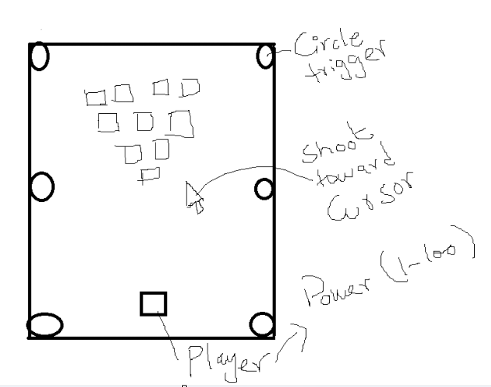

- Sprite Sheet
- Import the sprite sheet.
- Set Sprite Mode to Multiple.
- Slice it correctly using Sprite Editor.
- Use sliced sprites for player and objects.
- Player Square
- Must have:
  - SpriteRenderer
  - Rigidbody2D (Gravity Scale = 0)
  - BoxCollider2D
- A public power variable (visible in Inspector).
- Power continuously changes between 1 and 100.
- When Space is pressed:
  - Player shoots toward mouse.
  - Use Rigidbody2D.AddForce with Impulse mode.
- Target Squares
- Have Rigidbody2D and Collider2D.
- Can be pushed by physics.
- Get destroyed when entering goal zone.
- Goal Circles
- Have CircleCollider2D.
- Is Trigger enabled.
- If normal square enters → destroy + increase score.
- If player enters → Game Over.

- For the Continuous Power (1 to 100):
The player has a public float power.
It increases slowly every frame.
When it reaches 100, it resets back to 1.
public float power = 1f;
public float powerSpeed = 20f; // slower speed
void Update()
{
power += powerSpeed * Time.deltaTime;
if (power > 100f)
{
power = 1f;
}
}

- Getting Mouse Position in World Space
The mouse position is in screen space.
Physics works in world space.
So we must convert screen position to world position.

Vector2 mouseWorldPosition = Camera.main.ScreenToWorldPoint(Input.mousePosition);
Explanation:
- Input.mousePosition gives screen coordinates.
- ScreenToWorldPoint converts them into world coordinates.
- We cast to Vector2 because it is a 2D game.

- Shooting Toward Mouse on Space Press
When Space is pressed:
- Calculate direction from player to mouse.
- Normalize direction.
- Multiply by power.
- Apply AddForce using Impulse.
Rigidbody2D rb;
void Start()
{
rb = GetComponent<Rigidbody2D>();
}
void Update()
{
if (Input.GetKeyDown(KeyCode.Space))
{
Shoot();
}
}
void Shoot()
{
Vector2 mouseWorldPosition = Camera.main.ScreenToWorldPoint(Input.mousePosition);
Vector2 direction = (mouseWorldPosition - (Vector2)transform.position).normalized;
rb.AddForce(direction * power, ForceMode2D.Impulse);
}

Explanation step-by-step:
- mouseWorldPosition
Get where the mouse is in the game world.
- direction
Subtract player position from mouse position.
This gives a vector pointing toward the mouse.
- normalized
Makes direction length equal to 1.
So only direction remains, not distance.
- direction * power
Now the force strength depends on power value.
- ForceMode2D.Impulse
Applies an instant push like a shot.

Goal Zone Behavior
When something enters the trigger:
- If it is the player → Game Over.
- If it is another square → Destroy it and increase score.
- Students should use OnTriggerEnter2D and CompareTag() to differentiate between Player and other objects.

